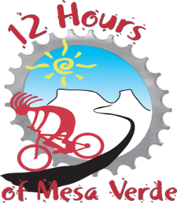
Beneficiary Application

Deadline: January 31, 2021
**Please return completed application to: info@12hoursofmesaverde.com

Organization Information
Name and brief description or mission statement:
Contact Person:
Phone:
Physical Address:
Mailing Address, if diff.:

Organization History and Future Plans
How long has this organization been established:
Have you been a beneficiary of ours in the past, when & what years:
If so, how have the funds been used in the past:
How would funds be used in the future (all applicants):
Please indicate the approximate number of youth served and/or hope to serve:
Describe the services and/or events that your organization does that serves youth in our community:

